Application Number | 07/ 2016/0591/OUT
Address | Land Off Shaw Brook Road and  Altcar Lane  Leyland  Lancashire
Applicant | Redrow Homes Lancashire Ltd
Development | Variation to the Section 106 Agreement to provide for a commuted sum in lieu of affordable dwellings on site Ref: 07/2016/0591/OUT.
Officer Recommendation  Officer Name | To seek delegated authority to vary the Section 106 Agreement to provide for a commuted sum in lieu of the 20% on site affordable dwellings.  Mrs Catherine Lewis

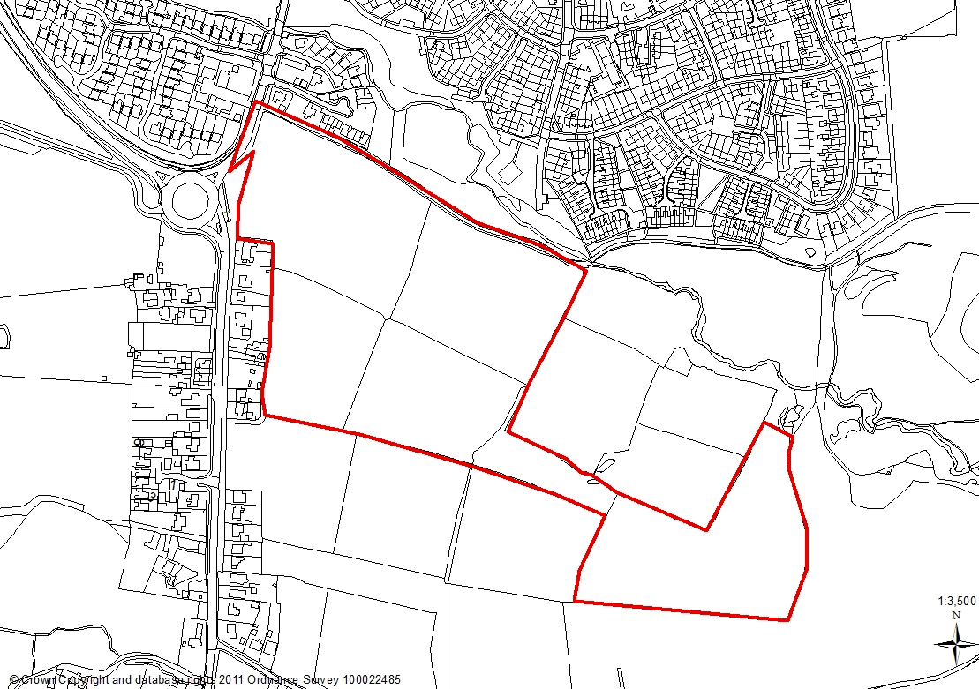

1.0 Report Summary

1.1 Outline planning permission was granted for up to 400 dwellings and associated infrastructure following the successful completion of a Section 106 Agreement in September 2017. The Affordable housing contribution element of the Section 106 required 10% as a commuted sum for provision off-site and 20% starter homes or discounted open market value (DOMV) units on site.

1.2 Due to the failure of the Starter Home initiative and the recent changes to lender requirements obtaining mortgages for DOMV units Redrow has advised that this tenure has become less financially attractive to sell. Under the current Section 106 agreement if these properties have not sold in six months a commuted sum is paid to the Council.

1.3 Redrow has requested that the Section 106 be varied to bring forward this payment. The Council’s viability assessor has sense checked the information and in principle is in agreement. They have recommended some caveats to be put in place with regard to the timing and calculation of the off-site commuted sum which have been agreed by the applicant. These changes ensure that any off-site commuted sum is based upon the most recent Land Registry prices which is a transparent and fair way to calculate such a sum.

1.4 The variation of the Section 106 to bring forward the commuted sum instead of the 20% on site affordable housing is recommended for approval as per the officer recommendation.

2.0 Site and Surrounding Area

2.1 The application site is located approximately 2km south of Leyland town centre and forms part of a wider residential development. Shaw Brook Road forms the northern boundary, with residential properties previously approved under permission 07/2018/1674/REM to the west and southern boundaries. The eastern boundary has permission in outline form for residential development and therefore no formal details have yet been submitted for this aspect.

2.2 Construction is currently taking place on part of the wider site. Public Footpath number 46 runs east from Leyland Lane along part of the southern boundary of the site boundary. This path joins Footpath 20 which runs north from Altcar Lane and continues north to meet with Shaw Brook Road.

2.3 There are two locally designated Biological Heritage Sites (BHS) in proximity to the application site: Shaw, Altcar and Ruin Woods BHS, is located on the eastern boundary and Brickfield Wood BHS, approximately 250m to the north of the site.

3.0 Planning History

3.1 A Masterplan has been endorsed by the Planning Committee in March 2016 for up to 600 residential properties which included two access points one to the north to serve the Redrow Homes development and one to the south off Leyland Lane to serve the Homes and Community Agency (HCA).

3.2 Outline planning permission has been granted for the Redrow Homes application for up to 400 dwellings to be served from the northern access point (Ref:07/2016/0591/OUT). This application is subject to a Section 106 agreement which requires:

- Delivery and Financial Contribution to Worden Park of £123,000
- Financial Contribution to the Travel Plan of £24,000
- Affordable Housing:
- 10% Off site Housing Contribution
- 20% On site Affordable Housing
- Management of Open Space

  - A number of applications have been submitted for the details reserved by condition.

  - 07/2018/1674/REM Reserved Matters (appearance, landscaping, layout, and scale applied for) for a residential development of 232 dwellings at land near Shaw Brook Road. Approved July 2018.

  - 07/2019/0300/REM Reserved matters (appearance, landscaping, layout, and scale applied for a re-plan of 87 dwellings Approved January 2020.

  - 07/2020/00935/REM Application for Reserved Matters for residential development for 54 dwellings (Appearance, Landscaping, Layout and Scale) applied for 07/2016/0591/OUT.

4.0 Proposal

4.1 To vary the Section 106 Agreement dated 20 September 2017 to bring forward the payment of a commuted sum instead of the 20% discounted open market value (DOMV) units to be delivered in site.

5.0 Material Considerations

5.1 The South Ribble Affordable Housing Supplementary Planning Document (SPD)requires 30% of dwelling to be affordable units. In September 2017 planning permission was granted for the provision of 400 dwellings of which 20% of the Affordable Housing would be sold as either Discounted Market Units or Starter Homes. In both cases the homes would be sold at an affordable price which is 80% of the Open Market Value. A commuted sum would be paid to SRBC in lieu of the final 10% of units.
5.2 Due to the failure of the Starter Homes initiative, Redrow Homes have progressed on the basis that the Affordable Housing was to be disposed of as Discount Market Units in accordance with the terms of the Section 106.
5.3 The applicant has recently advised that: Following the onset of the Covid-19 pandemic, Redrow became aware of recent changes to lender requirements in respect of offering mortgages for this tenure type. Specifically, through our discussions with mortgage advisors RCS, we understand that the only mortgages currently being offered for this tenure type are those with a 15%+ deposit. This level of deposit tends to be unaffordable to many prospective purchasers, especially where account is taken for fact that these are a proposed Affordable Housing tenure. Unlike other market changes which have proved temporary, this requirement in relation to Discount Market Units remains in place, raising serious questions as to the saleability and affordability of the affordable housing tenure.
5.4 A comparison table has been provided comparing a purchaser buying a £200,000 house under the Discounted Market model, alongside Help to Buy (where the purchasers benefit from a LTV of 75% with a 5% deposit).
5.5 As can be seen from the table below, not only does the Help to Buy purchaser pay less than half of the deposit, they also end up paying less per month in mortgage payments. This significantly undermines the status of the Discounted Market Units as ‘Affordable Housing’, with a Help to Buy purchase of the same property on the open market being more affordable in most cases. As well as affordability, the purchaser of the property using Help to Buy would also benefit from being able to sell at 100% of MV, without the eligibility criteria stated in the Section 106. This raises a concern for the applicant in finding suitable purchasers for the properties, as well as potentially leaving any purchasers in a position where an acquisition on the open market would be more affordable.

 | Discount Market | Help to Buy
Market Value | £200,000
Purchase Price | £160,000 | £200,000
Buyer Deposit | £24,000 (15%) | £10,000 (5%)
Help to Buy Loan | - | £40,000
LTV | 85% | 75%
Mortgage Rate | 2.75% (Barclays DMV via RCS) | 1.59% (Barclays website)
Mortgage Amount | £136,000 | £150,000
Monthly Payments (assuming 25 year term) | £627 | £606
Resale % | 80% | 100%

5.6 The above information has been sense checked by the Council’s Viability Consultants who have agreed in principle to the findings. They have recommended some caveats to be put in place with regard to the timing and calculation of the off-site commuted sum which have been agreed by the applicant. These changes ensure that any off-site commuted sum is based upon the most recent Land Registry prices which is a transparent and fair way to calculate such a sum.

6.0 Other Options Considered

6.1 To continue to enforce the Section 106 as it stands. If there is no take up of the DMV within the time frames specified in the Section 106 the default position currently provides that if unsold after 6 month of marketing the affordable homes can become market value with Redrow paying the Council 20% of their sale value. Based upon the independent valuations the amount that would be payable is approximately £1,700,000.

6.2 If agreeable to the Council, Redrow would be open to varying the Section 106 agreement to bring forward payment of this sum (with account taken for any extra CIL payable) in exchange for the plots becoming open market sale without encumbrance.

7.0 CONCLUSION

7.1 The application site forms part of a wider housing site known as Site P under D1 of the adopted South Ribble Local Plan 2015. The site is a parcel of land that the Council wishes to see come forward for residential development. Planning permission has been granted for outline consent to provide for 400 dwellings, to-gether with Reserved Matters permissions for 232 dwellings.

7.2 The affordable housing provision at this site sought to be one of the first to provide Starter Homes a Conservative Government initiative in 2017. If the Starter Homes were not delivered, as part of the provisions within the Section 106, a fall-back position included the delivery of Discounted Market Homes (DMV). Due to the current housing issues including the ability to secure a mortgage the DMV units have become less financially attractive to first time buyers.

7.3 The variation of the Section 106 agreement would provide the opportunity for more open market homes to be available for first time buyers together with a commuted sum in lieu of the on-site affordable provision.

7.4 On that basis the variation to the Section 106 with regard to the land the subject of the following permissions 07/2018/1674/REM, 07/2019/0300/REM and 07/2020/00935/REM, each being pursuant to 07/2016/0591/OUT be supported insofar as it relates to the land currently owned by Redrow Homes.

8.0 RECOMMENDATION:

8.1 To seek delegated authority to vary the Section 106 with regard to the land the subject of the following permissions 07/2018/1674/REM, 07/2019/0300/REM and 07/2020/00935/REM, each being pursuant to 07/2016/0591/OUT insofar as it relates to the land currently owned by Redrow Homes. The Variation relates to the Council receiving a commuted sum instead of the 20% on site affordable housing provision.

RELEVANT POLICY

NPPF National Planning Policy Framework

1 Locating Growth (Core Strategy Policy)

- Housing Delivery (Core Strategy Policy)

- Housing Density (Core Strategy Policy)

- Housing Quality (Core Strategy Policy)

- Affordable and Special Needs Housing (Core Strategy Policy)

22 Biodiversity and Geodiversity (Core Strategy Policy)

- Crime and Community Safety (Core Strategy Policy)

- Sustainable Resources and New Developments (Core Strategy Policy)

29 Water Management (Core Strategy Policy)

POLA1 Policy A1 Developer Contributions

POLD1 Allocations of housing land

POLD2 Phasing, Delivery and Monitoring

POLF1 Car Parking

POLG9 | Worden Park
POLG11 | Playing Pitch Provision
POLG13 | Trees, Woodlands and Development
POLG16 | Biodiversity and Nature Conservation
POLG17 | Design Criteria for New Development

